**PRACTICAL NO : 03**

**THEORY:**

### **What is a Static Route**

A static route is a route that is created manually by a network administrator. Static routes are typically used in smaller networks. In static routing, the Router's routing table entries are populated manually by a network administrator.

The opposite of a static route is a **[dynamic route](https://www.omnisecu.com/cisco-certified-network-associate-ccna/what-is-dynamic-routing-and-different-types-of-dynamic-routing.php" \t "https://www.omnisecu.com/cisco-certified-network-associate-ccna/_blank)**. In dynamic routing, the the routing table entries are populated with the help of **[routing protocols](https://www.omnisecu.com/cisco-certified-network-associate-ccna/what-is-the-difference-between-routing-protocols-and-routed-protocols.php" \t "https://www.omnisecu.com/cisco-certified-network-associate-ccna/_blank)**.

The major advantages of static routing are reduced routing protocol router overhead and reduced routing protocol network traffic. The major disadvantages of static routing are network changes require manual reconfiguration in routers and network outages cannot be automatically routed around. Also it is difficult to configure static routing in a complex network.

### **What is a Default Route**

A Default Route (also known as the gateway of last resort) is a special type of static route. Where a static route specifies a path a router should use to reach a specific destination, a default route specifies a path the router should use if it doesn’t know how to reach the destination.

Default Route is the network route used by a router when there is no other known route exists for a given **[IP datagram's](https://www.omnisecu.com/tcpip/internet-layer.php" \t "https://www.omnisecu.com/cisco-certified-network-associate-ccna/_blank)** destination address. All the IP datagrams with unknown destination address are sent to the default route.

### **How to configure Static Routes**

Static Route can be configured by the following IOS commands.

• Router(config)#ip route destination_network subnet_mask default_gateway [administrative_distance] [permanent]

OR

• Router(config)# ip route destination_network subnet_mask interface_to_exit [administrative_distance] [permanent]

The permanent keyword will keep the static route in the routing table even when the interface the router uses for the static route fails.s

**Aim: Configure network with Static and default routing.**

**Step 1 : Take 2 PC’s and 4 routers.**

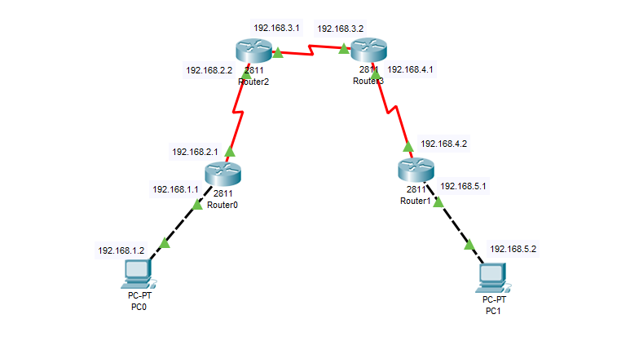

**Step 2 : Assign IP Address.**

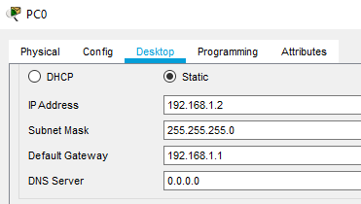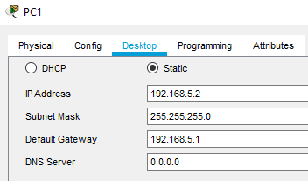

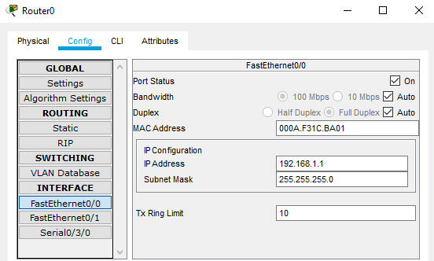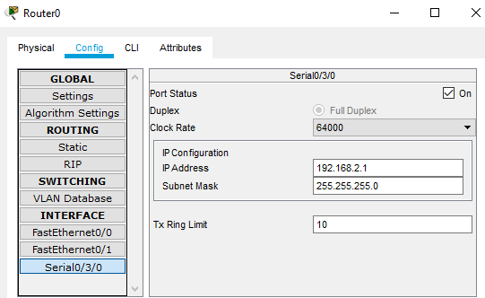

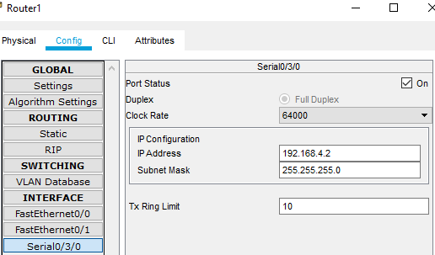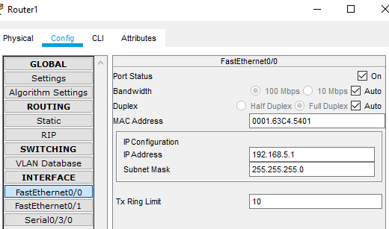

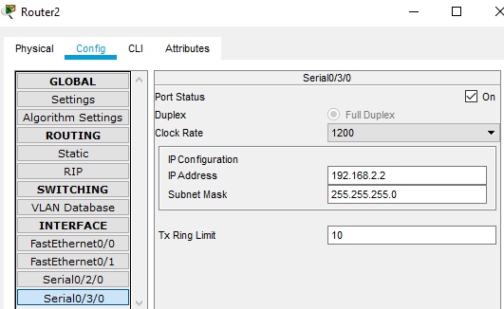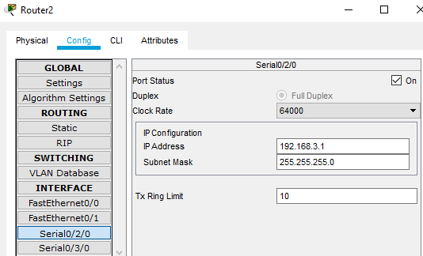

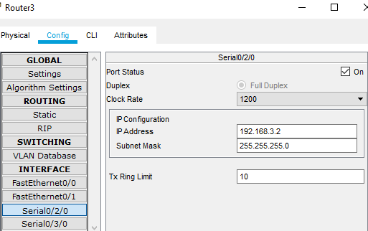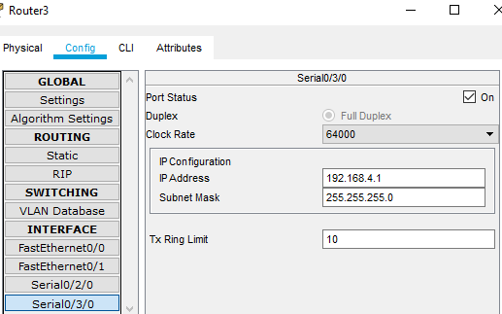

**Step 3 : Connecting Network for Static Routing (using network address, next hop)**

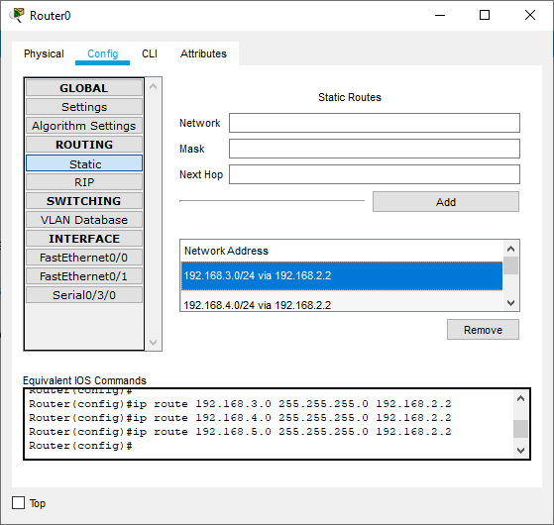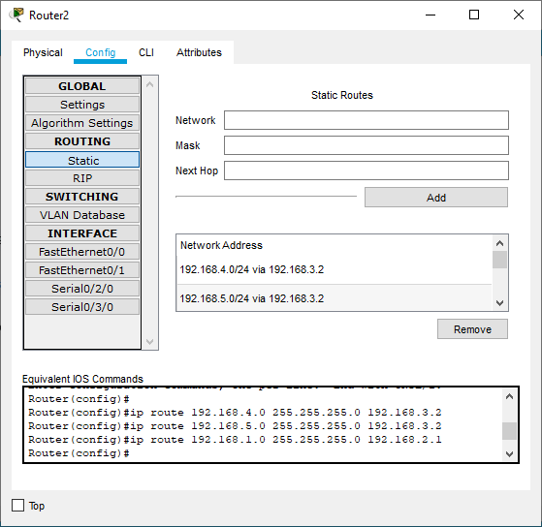

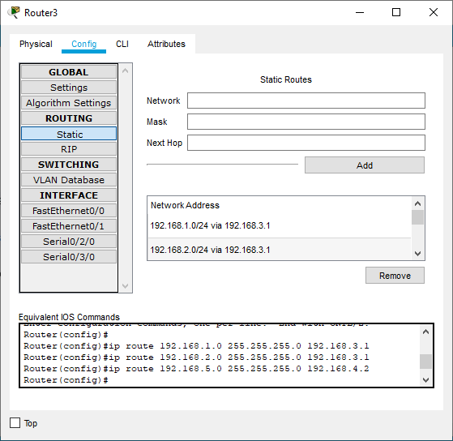

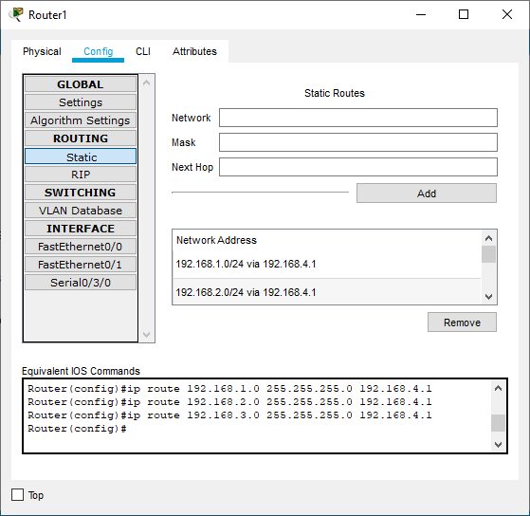

**Step 4 : Connecting Network for Default Routing (using network address, next hop)**

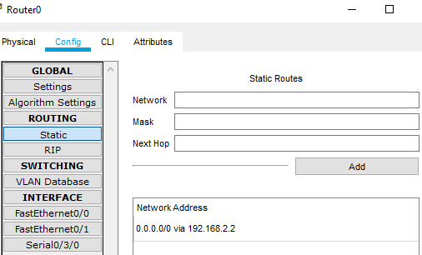

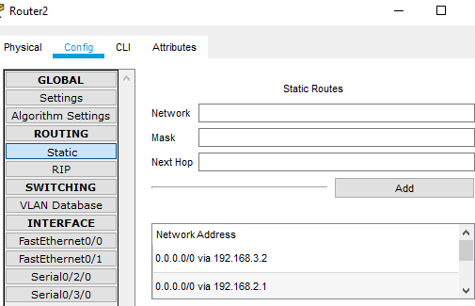

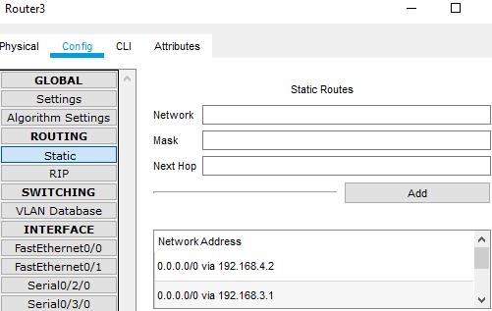

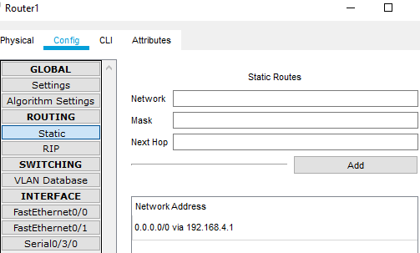

**Step 5 : Pass message from one pc to another.**

